Marshall Tuck
3/5/09
English 1106
Nicole Williams
Assignment 2: Lay of the Land
“Paleo and CrossFit: A Minimalist Design”
Easy to gather from my conversation with John Steger about Paleo is the idea of minimization. The way he eats stresses quality and quantity. He speaks about feeding himself with the foods that make him feel the best- not the best right now, but the best an hour from now. He “cuts the crap” from all of the sugars, processed foods, genetically modified organisms (GMOs), and anything else unnecessary to live. The idea, he explains, is to eat enough to support the activity you do, and with John being a Cadet Colonel in the Corps of Cadets, his activity level is high. Just how high I was soon to find out.
My first ten days of strictly following Paleo was as difficult as it sounds. In a strange way, it was heartbreaking to leave the foods that gave me the comfort I was used to: the ice creams, the macaroni and cheeses, the fried apples, the chicken nuggets, etc. I felt generally awful. I had low energy, shown by my inability to walk to campus anymore. The cravings I had around meal times were unendurable, and the thought of running again for fun seemed so far out of the picture. My head hurt at times for no reason, I caught myself taking a thirty minute nap every few hours, and I never was full after meals. It seemed the closet you could get to withdrawals from being truly dependent on a substance.
The food I ate was completely unappetizing at first. When I was hungry, I’d reach for the walnuts or the almonds or the cage-free hardboiled eggs, but my body just craved the foods I had all my life fed it amply. I would eat “clean” Paleo foods (“clean” in Paleo-speak means without added anything and all-natural), but I could never stop eating them. My handful of almonds that I reached for when I was hungry for a snack would turn into my eating an entire jar of almond butter. My can of tuna I would eat after my morning meals (my second of what was usually 5 or 6 eating sessions per day) would turn into 3 cans of tuna and an entire jar of coconut milk. But, I did my reading, and knew this was what to expect from such a cold-turkey attempt. “The important thing is,” John told me, “that you only eat Paleo foods. Don’t stray, because your body needs to learn how to use fats as energy instead of carbohydrates.”
What John spoke of, and what I read at length about, was a process called ketosis. The human body has an extraordinary mechanism from which to draw energy in the absence of carbohydrates, but this process doesn’t need to be tapped in our Western diet. When you consume a low amount of carbohydrates, your body, over a short time period, “rethinks” how it gets its energy for survival. Between the ranges of about 0-75 grams of carbohydrates per day, your internal programming has a second energy source it can tap into, the amazing, highly useful fat (Phinney, 2004). When your body has to break down fats for energy because of its low-carb and thus low-blood sugar environment, the liver gets inundated with fatty acids. These fatty acids are metabolized into ketones, which are then used by the body as an efficient fuel source in place of the simple carbohydrates to which it’s acclimated (Sisson, 2008).
Essentially, my body was refiguring how to live because it had been addicted for quite some time to the insulin rushes characteristic of eating grains and simple sugars. For ten days I hurt. Then about a week and a half into the diet, I woke up and was no longer tired. I was wide awake, a little hungry, and felt good. I kept eating Paleo and over the next few days kept feeling better and better. The meals I ate became smaller in portion as I got full on less and less food from the dining halls on campus, and I started tinkering with supplements. For the next week after that, I remained on strict Paleo eating, eating a diet that was roughly:
Breakfast- 8 A.M.
6 whole eggs, 18 almonds, 1 orange, and a small cup of coffee (which was soon phased out)
Pre-Lunch- 10:30 A.M.
2 tablespoons of almonds butter, 10 walnut halves
Lunch- 2 P.M.
2 whole chicken breasts, a large spinach salad with carrots, mushrooms, broccoli, all soaked in extra-virgin olive oil
Pre-Dinner- 4 P.M.
1 apple, 1 cup of canned tuna fish
Dinner- 6:30
Steamed Vegetables (zucchini, squash, mushrooms), 20 pecans, and a large helping of turkey or chicken or pork
Post-Dinner-10 P.M.
1 can of coconut milk, watered down to taste, with some organic cinnamon and blueberries
I ate solidly like that for about a week, during which I became really excited about the new way that I felt and, to a lesser extent, looked. The body fat I had that I convinced myself I needed to run long distances started melting off, and I started running again at a faster pace and over longer distances than I had in the past. I looked into what more I could do to improve myself, and I started tinkering with fish oils, different multivitamins, Vitamin D, and probiotics (naturally-occurring gut bacteria).
John and I, along with another hardcore Paleo-er Justin, would talk at length about what they had tried, what they had found worked, and what they were willing to do become better athletes and more fit Cadets. I soon took a large leap into the entire culture, more so than I already had. From speaking with John and Justin, I assumed that the diet was the main focus of their health, that their diet alone allowed them to run at machine-like speeds over superfluous distances and then report to Formation (a daily ritual of the Corps of Cadets at 7:30 A.M.) What I was curious about soon took me into the deeper workings of the lifestyle, into the mainframe of Paleo, and showed me just how deeper the culture went.
Cadet Colonel John Steger
According to Mark Sisson of marksdailyapple.com, your body composition consists of 80% of your diet and 20% of your exercise regimen. And although I found a great way to achieve 80% easily (well, not so easily), I soon discovered the other 20%.
CrossFit
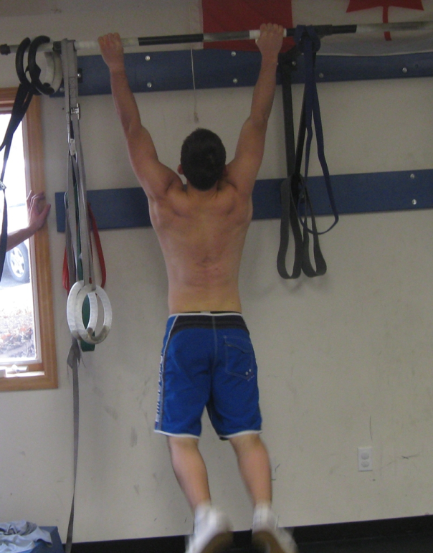
Speaking to Justin and John one day after an organizational meeting for a club on campus, they spoke fluently in a language I didn’t quite understand. They spoke of “burpees,” “Fran,” and “snatches,” and I was completely lost. Prodding for more information, I found that they were both members of an elite school of fitness- the quintessential epicenter of Paleo, where these words were the norm, and were actually movements. CrossFit was the (cage-free) chicken, Paleo was the (organic, enhanced with Omega-3’s) egg. Still having a strange image in my head, I asked more questions, attempting to get my head around the idea. They answered my preliminary questions in fragmented sentences, told me they couldn’t quite explain it, but did manage to relay the fact that it was “hardcore” and, well, “different.” Hmmm… So, of course, I checked it out as soon as I could, addicted to this great idea of goodness and searching for more ways to improve myself.
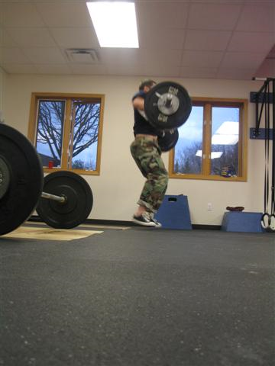
I quickly e-mailed the Coach of the gym (translated: the owner) and signed up for the first information session I could. Letting me know that I could come that next day at 2 P.M., I was ready to find out what the hype was about. Pulling into the parking lot fifteen minutes early, I figured I had plenty of time to find a gym. How different can gyms look? I looked, and I didn’t find. I saw a massage therapist office with a back door and a Tae Kwon Do building, but I saw no gym that could produce some of the fittest people at Virginia Tech. Turns out the back door to the massage studio was the gym. Different? I’d say so. I walked into a room no larger than my living room at home, a room covered with a floor-length rubber mat that smelled like sweat. In the corner of the “gym” were 4 stacks of Olympic-style weights, ranging from 10 lbs to 45 pounds. Up against the walls, starting at noon and going clockwise around the room, were 3 white boards with at least 75 names written and numbers next to each, a few windows, 5 tough-looking pull-up bars taped for your hands, a hook with at least 10 jump ropes, a few dumbbells, a few kettlebells, a couch, a computer, a sink, and 6 blue boxes labeled with bold black numbers. Oh yeah, I almost forgot! And at least 8 people dripping sweat, sprawled out on the floor in what looked like a war scene. I had found homebase. Scribbled on one whiteboard was “Lean Meats, No Sugars!” and underneath were listed two books named The Paleo Diet and Good Calories, Bad Calories by esoteric authors, along with what looked like a head a broccoli and an apple.
The workout from before my introductory session: Power Cleans
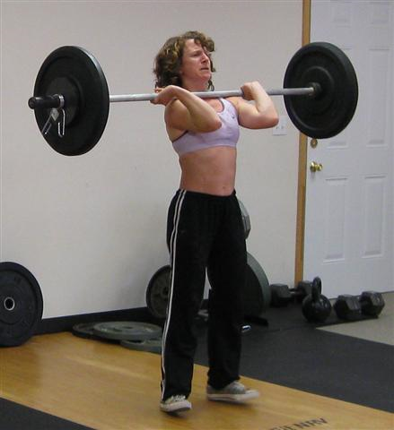
Sitting in the chair right in front of me was the Coach, Amy. She sat in her chair quickly answering emails on her computer in front a desk adorned with a bottle of 1000 mg/teaspoon EPA/DHA Fish Oil. In her bare feet, a sweatshirt emblazoned with “CrossFit Blacksburg” across the chest, and some Adidas long pants, she offered words of encouragement to the corpses (now beginning to stand up) and gave out copious high-fives. As everybody made their way out of the room (“Bye Amy! See you when I can stand without support again!”), Amy introduced herself to me and motioned for me to sit down on the couch. What followed was a brief breakdown of the idea of CrossFit: high intensity, functional movements performed powerfully. Revolving around the basic ideas of Olympic lifting (the power clean, the jerk, the squat, and the snatch), the idea of CrossFit was to condition one to have real strength, not just bicep-curl-strength.
Coach Amy
Then came the question of nutrition. “How’s your diet?” Luckily, for the first time this meeting, I was able to know a little about the topic of conversation. We talked about diets, and she reinforced my working knowledge of Paleo with her own anecdotal evidence of her health improvements over the 3 years she’s been “clean.” 3 years??!! Telling me she never knew how bad she felt until she started eating better, she applied her own knowledge to my experiences with Paleo, but encouraged me that the positive aspects for outweighed the inconvenience of it.
What came next was something I was not exactly expecting. Over e-mail, she said she would put me through a quick workout to assess where I was physically (I had been a recreational runner for years, and had even finished with a respectable half-marathon time a month earlier). No problem, Coach! I assumed maybe a mile jog, a few jumping jacks, whatever. I brought my running shoes, and was ready for what I thought was going to be a cookie-cutter workout. Not so fast there, Turbo. Lacing up my tennis shoes, Amy asked me where I was going with a hint of sarcasm. “Um, just ready to work out, I guess?” was my not-so-assuring response. Letting me know that it’s beneficial to workout in bare feet to gain a more natural, organic feel, I slipped my shoes off and tried to play off my misstep.
The workout she put me through was called “The Baseline.” Funny, this looks like it could be a pretty high line to be considered Base. Baseline seemed to be, well, a baseline for everything. Every member of CrossFit Blacksburg had their name and time for Baseline written on the white board, with times ranging from 3:30 to just over 9 minutes. Amy wheeled out a rowing machine, and told me I’d be doing a timed 500 meter row, into 40 deep squats, into 30 unanchored sit-ups, into 20 pushups, into 10 pull-ups. She said “GO!” and I went into the workout in a fury. By squat 3, I knew I was hopeless. My legs felt like jelly and my calves were burning. Uh-oh. Muscling my way into my last pullup (needing help from an elastic band), I dropped onto my hands and knees, breathing heavily, not being able to talk. I felt like the people I had just replaced, and could still feel the sweat still very much unevaporated from the people twenty minutes before.
Not able to walk the next day, I knew I had done something right. I signed up for a semester membership as soon as I could grip a pen and move my arms enough to sign the check, which, laughably, was about three days later. Essentially wasting away on the floor, a sweaty clump of college kid in an old teeshirt and a thicket of hair, I understand the simplicity of everything. Everything in this subculture is minimal, because that’s the best way to do it. No fancy machines, just your body weight, a few functional movements, your bare feet, proper technique, and a stopwatch.
This was the main vein of Paleo; people of all ages and abilities come here first and get turned onto Paleo second. Although I happened to do it the opposite way, the message nevertheless got across loud and clear. There’s no room for vanity when you truly want to make yourself an exceptional athlete at the pinnacle of your own health. You just need to have the will power and the determination to eat and exercise the right way. Not longer than anyone else necessarily, and certainly not with the idea to get bulging biceps. CrossFit, and its accompanying diet, Paleo, coupled with a little hardwork can make anyone the natural athlete we’re genetically designed to be. With all of the new lifestyle information I gathered from CrossFit and Paleo, I realized we owe it to ourselves to function at a point that optimizes the rare feeling of good. We can accomplish this working minimally, even naturally with our environment. After Baseline, dripping sweat and coughing uncontrollably, Amy left me with this bijou of information: “It’s about getting the most out of the least.”

Works Cited
Phinney, Stephen D. “Ketogenic diets and physical performance.” 17 Aug 2004. Online. Accessed 2 March 2010. <http://www.nutritionandmetabolism.com/content/1/1/2>.
Sisson, Mark. “Primal Living in the Modern World.” 30 June 2008. Online. Accessed 3 March 2010. <http://www.marksdailyapple.com/dear-mark-ketosis>.

